School Of Mechanical And Manufacturing Engineering, NUST

Department Of Mechanical Engineering

**CS-104 – Fundamentals of Programming**

### Lab Assignment #1

##### 

**Course Instructor**: Dr Khwaja Fahad Iqbal

**Lab Instructor**: Muhammad Affan

Student Name: Muhammad Furqan Ul Arsh

CMS ID: 476347

Due Date: October 4, 2023

Task 1: Write a C++ code to calculate a factorial of 6.

Solution:

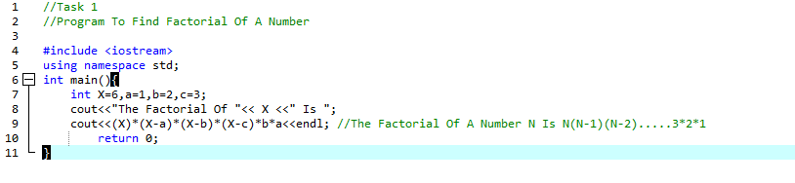

Task 2: Write a C++ program to calculate distance between two points .

Solution:

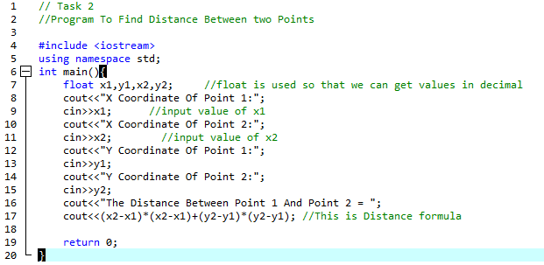

Task 3: Write a code in C++ to take length from user in centimeters and convert it into meter and kilometer.

Solution: 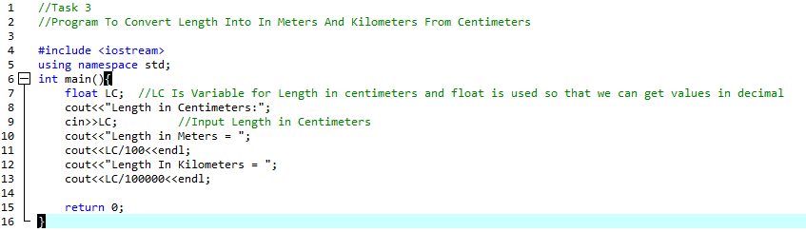

Task 4:Write a code in C++ that takes values of a and b from the user and displays result of polynomial.

Solution:

